
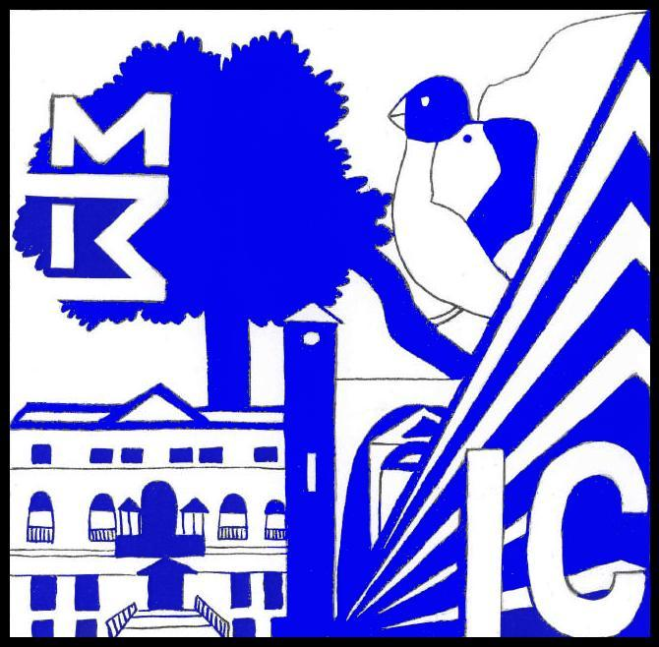

ISTITUTO COMPRENSIVO MOZZECANE

con sedi di Nogarole Rocca – Mozzecane
Via D. Alighieri, 39 - 37060 - Mozzecane (VR)
 045/8240025 Fax 045/8240026 vric895002@istruzione.it
C.F. 93221240232 COD. MEC. VRIC895002
www.icmozzecane.it

MATERIA: ___________________________________________________________________________

TESTO PROPOSTO per l'a.s. 2015/16
Titolo
Autore
Casa Editrice
Volume
Prezzo
Codice Isbn

IN SOSTITUZIONE del testo : ___________________________________________________________

Motivazione
_____________________________________________________________________________________________________________________________________________________________________________________________________________________________________________________________________________________________________________________________________________________________________________________________________________________________________________________________________________________________________________________________________________________________________________________________________________________________________________________________________________________________________________________________________________________________________________________________________________________________________________________________________________________________________________________________________________________________________________________________

data firma

Visto, il Dirigente Scolastico
________________________

Allegato 1

